# Project Overview

## Project Name & Description

Name: Reusable Blood-Giving Set for Pothiwira Surgical Center

The project focuses on developing an affordable, reusable, and sterilizable blood-giving set for the Pothawira Surgical Center in Salima, Malawi. Given the region’s high maternal mortality rate and limited access to blood transfusion supplies, the clinic faces critical shortages that delay life-saving procedures. The design integrates a durable twist-and-lock mechanism, a redesigned drip chamber for enhanced filtration, and a roller clamp for precise flow regulation. Materials such as platinum-cured silicone and stainless steel ensure biocompatibility and sterilization compliance. Testing confirmed the system’s ability to withstand compressive forces and effective bacterial removal after autoclaving. This solution aims to provide a sustainable alternative to single-use transfusion sets, improving patient care and healthcare accessibility in the region.

## Objective & Goals

Our primary goals for our project are:

1. Our design must be safe and sterilizable by passing tests that include bacterial removal, blood adhesion, and biocompatibility.
2. Make our design be durable, withstanding certain compressive strength and a drop test.
3. Ensure that our design is functional, including being easy to use, having no leakage, having flow modulation, having filtration, and is a compact size similar to standard disposable blood-giving sets.
4. Our design must fit community design requirements, including community comfort, use locally sourced materials, and low cost.

## Bill of Materials

[Bill of Materials](https://docs.google.com/spreadsheets/d/1cqrfP7p347UXdv-eoOeXX8uZQHe5CB9nxKuMcwCITTk/edit?usp=sharing)

# Testing Procedures & Results

* Since we have all our testing from last semester already included in the git, maybe just add this new test to that document and link here?

## 

# 

# 

# 

# 

# 

# 

# 

# Assemebly & User Guides

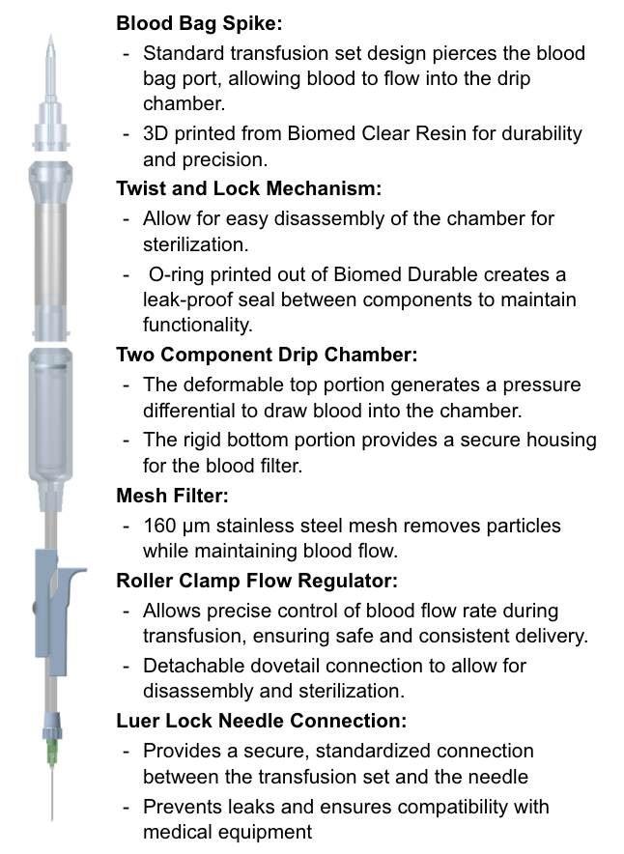

## 

## Assembly of Set

1. Obtain the components listed above
2. Place the filter inside the rigid drip chamber
3. Twist and lock the flexible drip chamber to the rigid drip chamber
4. Attach the flow regulator to the tubing from the rigid drip chamber
5. Twist and lock the other side of the drip chamber of the spike
6. Attach the needle connection to the bottom of the tubing from the rigid drip chamber

## 

## Disassembly & Sterilization of Set

1. Throw away the needle
2. Deconstruct the transfusion set by untwisting the spike from the flexible drip chamber and the rigid drip chamber.
3. Remove the filter cage from the rigid drip chamber
4. Place the 5 separate components (spike, flexible drip chamber, rigid drip chamber, and flow regulator) into the wash prior to autoclaving
5. Transfer the components into the autoclave and start a cycle of sterilization for 30 minutes at 121 ° C
6. After the cycle completion, remove the components

# 

# Next Steps & Recommendations

### **Unresolved Challenges**

Adhesive Selection:  
 Finding a fully compliant adhesive remains an unresolved challenge. Both DOWSIL 734 and Infinity Bond adhesives failed to meet durability, biocompatibility, or sterilization requirements. Future work must identify a medical-grade, ISO 10993-certified adhesive capable of withstanding repeated autoclave cycles.

O-Ring Sizing and Performance:  
 The current O-ring design requires excessive compression at full engagement and does not provide a consistent seal across the locking range. Redesigning the O-ring geometry and groove depth is essential to create a reliable seal without placing unrealistic demands on assembly force.

Tolerancing of Components:  
 Variability in printed part dimensions has resulted in inconsistent assembly, poor sealing, and occasional mechanical failures. Further refinement of CAD models and manufacturing processes is necessary to achieve tighter dimensional control and consistent fit across all components.

Blood Adhesion and Surface Geometry:  
 Testing revealed residual blood in complex geometries and in sections with adhesive, posing a risk for incomplete sterilization. Smoother surface transitions, larger radii, and minimized internal crevices in addition to a medical grade adhesive are needed to improve sterilization outcomes and minimize infection risks.

### **Design Change Recommendations**

### Source a Medical-Grade Adhesive: The team should prioritize identifying a biocompatible, autoclavable adhesive, such as a medical-grade two-part silicone or epoxy. Early validation testing is critical to ensure that the new adhesive maintains strength and integrity through sterilization cycles.

Revise O-Ring Design:  
 Future prototypes should incorporate thicker O-rings and deeper seating grooves to allow gradual compression and better sealing. Expanding the compression zone can help accommodate small tolerancing inconsistencies without sacrificing seal integrity.

Introduce Modular Tubing Replacement:

Consider a design where the tubing is detachable and disposable after each use, while the hard components remain reusable. Quick-connect fittings could make the device safer, easier to sterilize, and better aligned with clinical workflows.

Improve Surface Geometry:  
 Components should be redesigned with polished surfaces, rounded internal geometries, and minimized seams to reduce blood adhesion. Post-processing of 3D-printed parts could further enhance sterilization efficacy.

Expand Mechanical and Functional Testing:  
 Subsequent prototypes should undergo full mechanical validation, including tensile, fatigue, and high-pressure leakage testing. Aligning testing protocols with ISO 1135-4:2015 standards will help prepare the device for future clinical approval and deployment.

## Key Partners and Contacts for Follow-up

Student Team Contacts

Hannah Kragt - [hannah.kragt11@gmail.com](mailto:hannahkragt@gmail.com)

Jason Hoffman - [hoffman.jason21@gmail.com](mailto:hoffman.jason21@gmail.com)

Darcy Ayers - [darcy.ayers@gmail.com](mailto:darcy.ayers@gmail.com)

Michaela Harris - [mharris3002@gmail.com](mailto:mharris3002@gmail.com)

Advisor Contacts

Megan Madonna - [megan.madonna@duke.edu](mailto:megan.madonna@duke.edu)

Partner Contact

Anne Alaniz - [abalaniz@houstonmethodist.org](mailto:abalaniz@houstonmethodist.org)